**Part 1: Code Development**

1. Provide a screenshot of the project-23 folder with the code visualization folder, airflow-docker folder, and assignment.py file within it.

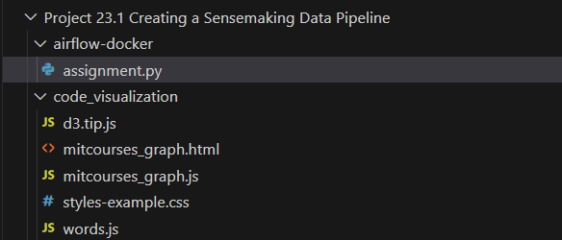

1. Provide a screenshot to show that you have imported the DAG object, the *operators*, and all of the necessary *task functions* into the assignment.py file.

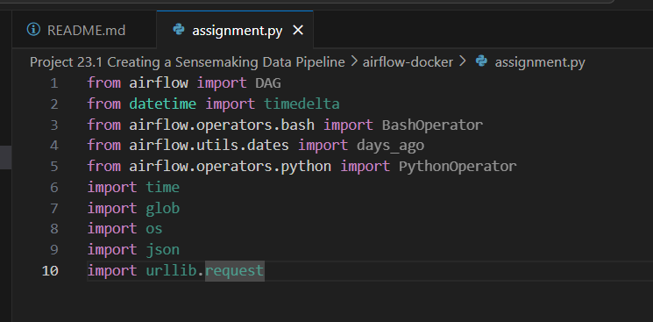

1. Provide a screenshot of the pull(url)and store(data, file)helper *functions* defined inside of the catalog()*task*.

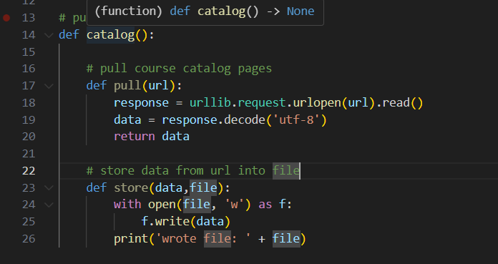

1. Provide a screenshot of the entire catalog()*function*, including the urls *list* and the for *loop* that you just implemented.

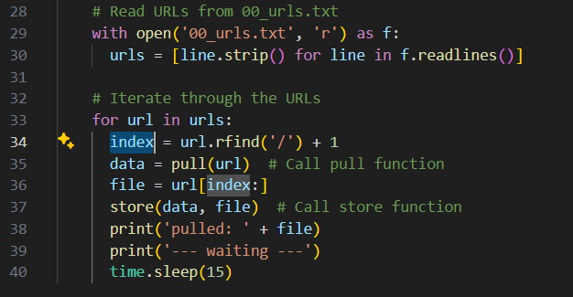

1. Provide a screenshot of the combine()*method* with the correct code to combine the files.

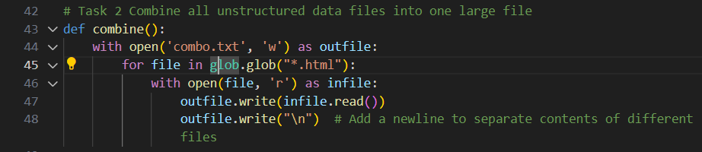

1. Provide a screenshot of the completed titles()*method* with the correct code to open and read the HTML file generated by the combine()*function*.

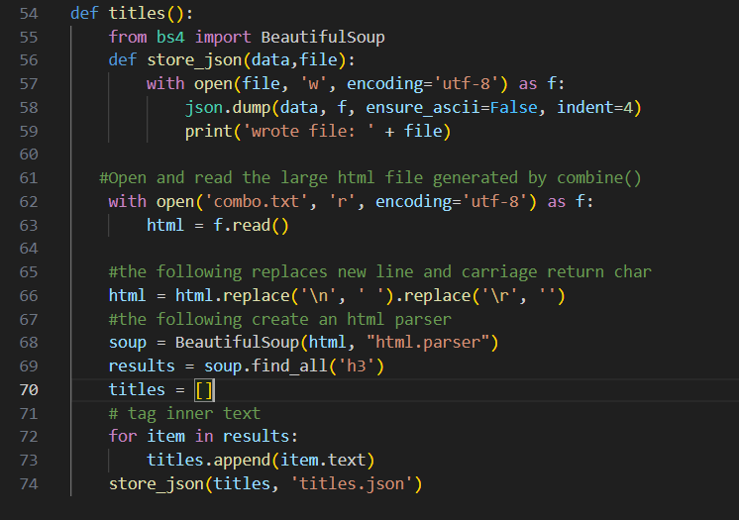

1. Provide a screenshot of the fully implemented clean()*method* with the correct code to remove all punctuation, numbers, and one-character words from the titles.json file.

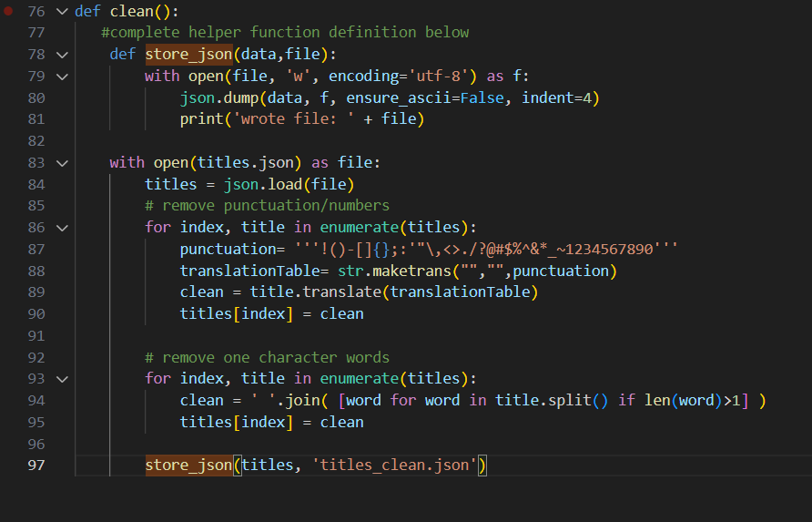

1. Provide a screenshot of the completed count_words()*method* with the correct code to call the store_json(data,file)helper *function*.

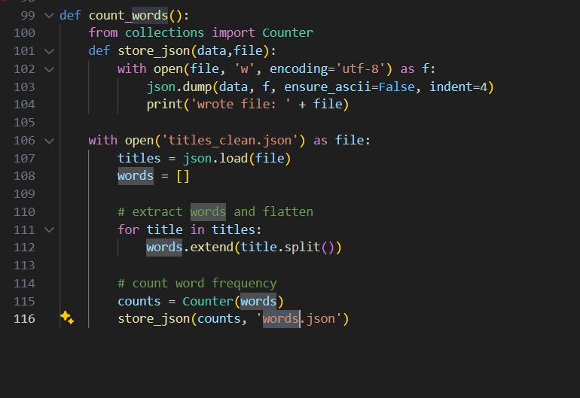

1. Provide a screenshot of the DAG declaration with all six *tasks,* from t0 to t5, correctly defined.

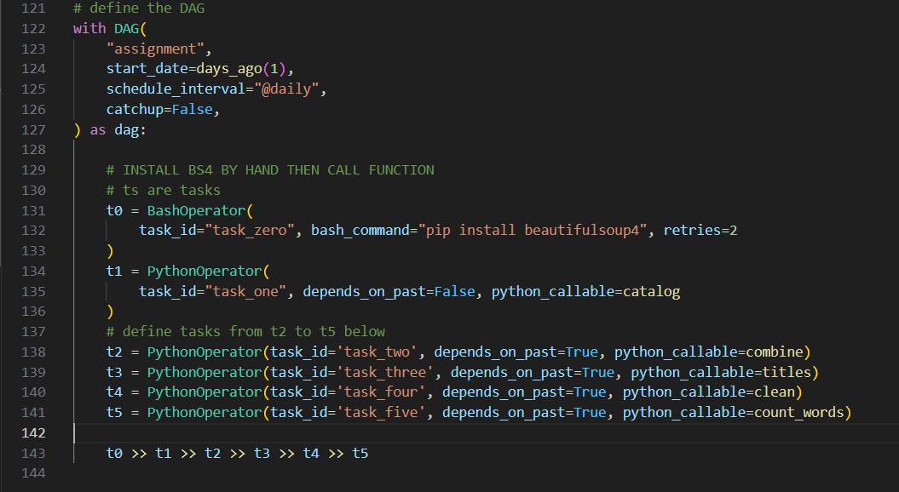

**Part 2: Code Execution**

1. Provide a screenshot of your Docker application that shows that your Airflow Docker *container* has initiated.

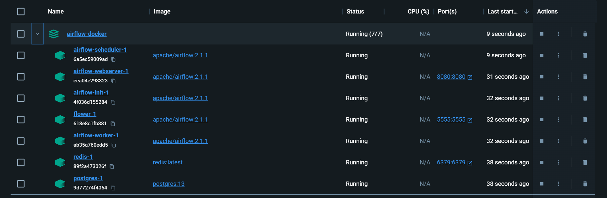

1. Provide a screenshot of the *task* boxes to show that the DAG ran successfully.

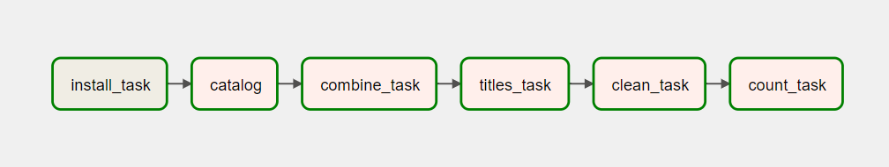

1. Provide a screenshot of the words.js file with the data from the words.json file. You may not be able to fit all the data in one screenshot. If so, the first part of the file is sufficient.

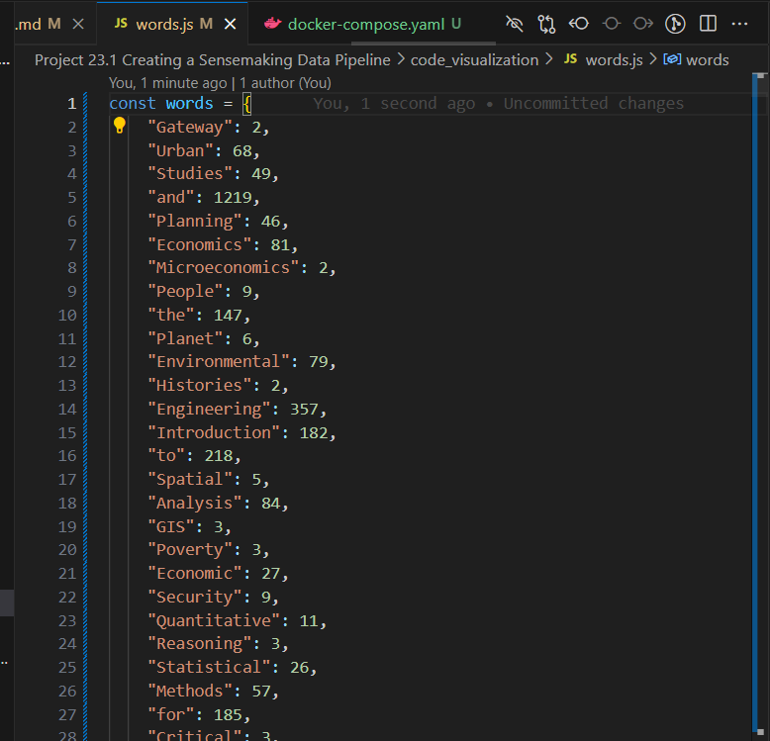

1. Provide a screenshot of the visualization produced with the mitcourses_graph.html file in your web browser.

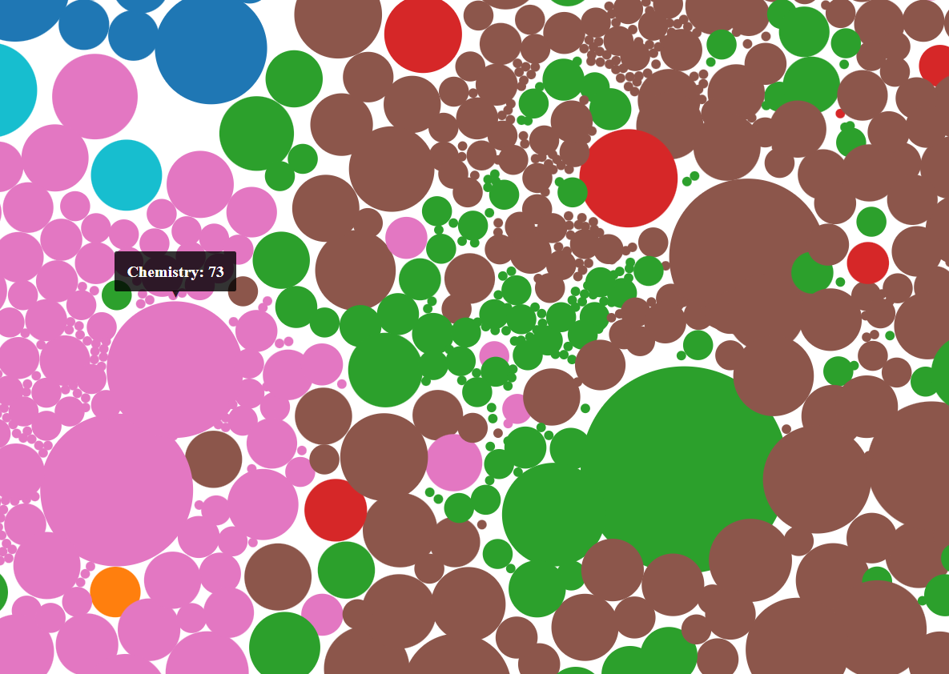

1. Provide a screenshot of your enhanced visualization created with the D3 *library* and the modified example code.

